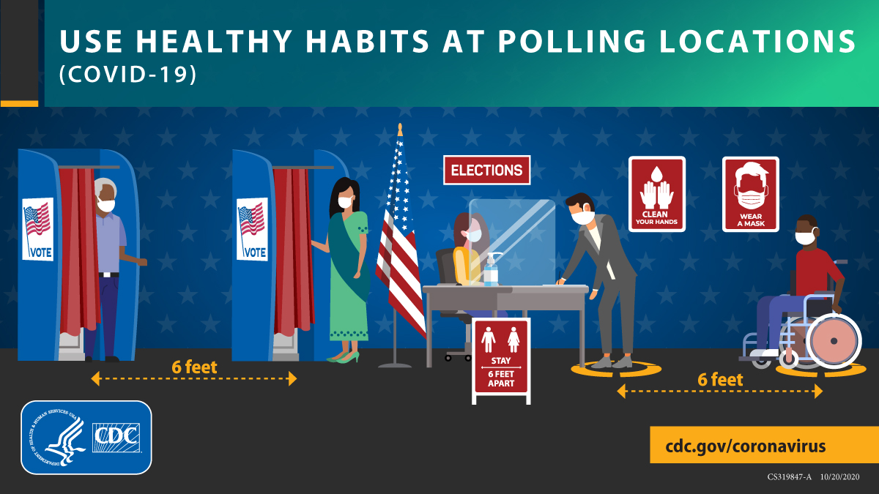

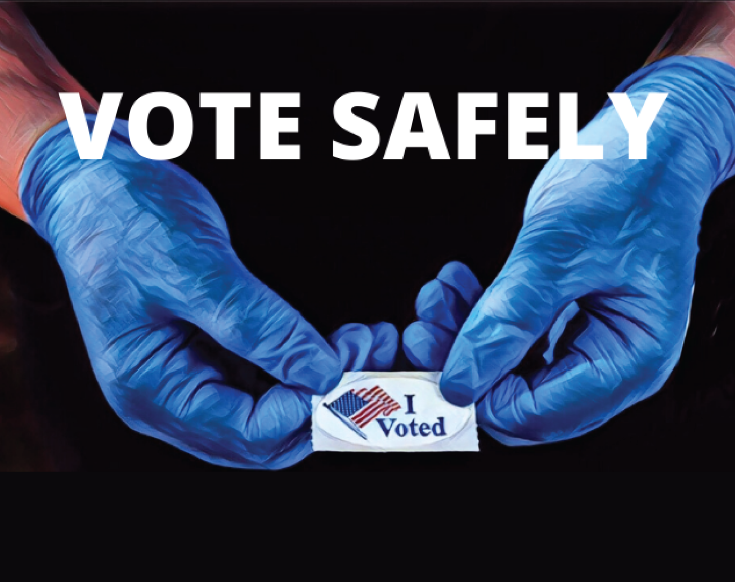

* Q-tips will be provided for voting equipment in place of fingertips

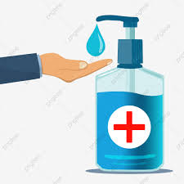

* Poll workers will be required to wear face mask or face shields
* Cleaning and disinfecting will be done rouinely throughout the day after each voter is done

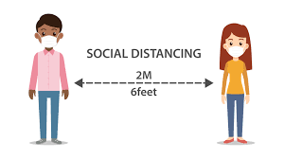

* Hand sanitizer will be available at every polling location

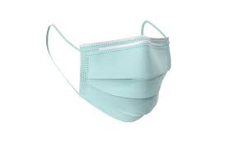

How do we plan to keep you safe while voting?

* Social distancing practices will be in place

